Journal of Geophysical Research Atmospheres
Supporting Information for
Exploration of Predictors for Statistical-Dynamical Subseasonal Prediction of Western North-Pacific Tropical Cyclone Activity in Earth System Models
K.A. Hansen1, M.A. Janiga2
1 National Research Council, 2Naval Research Lab Marine Meteorology Division
Contents of this file
Figures S1 to S6
Introduction
This supporting information provides additional figures referenced in the main article.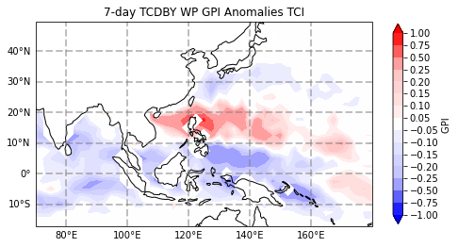
Figure S1. GPI anomalies associated with the top third of subseasonal TC events as measured by TC days as in Fig. 3 but the environment within 500km of TC’s are not removed.
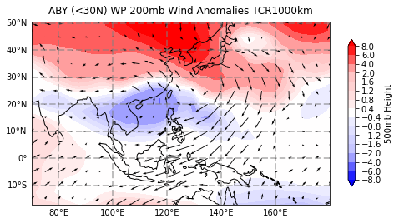
Figure S2. 200mb level wind anomalies (vectors) and 500mb height anomalies associated with the top third of subseasonal TC events as measured by TC day.

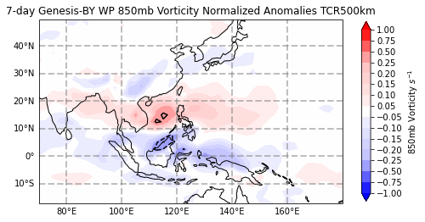
Figure S3. Normalized vorticity anomalies associated with the top third of subseasonal TC events as measured by TC genesis. The bold contours indicate the threshold where anomalies are significant at the 95% level.
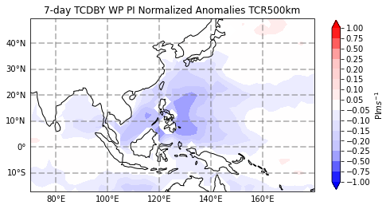
Figure S4. Normalized potential intensity anomalies associated with the top third of subseasonal TC events as measured by TC days.
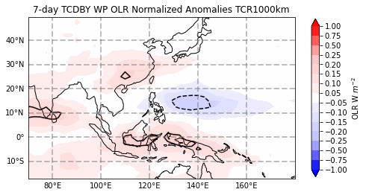
Figure S5. Normalized vorticity anomalies associated with the top third of subseasonal TC events as measured by TC genesis. The bold contours indicate the threshold where anomalies are significant at the 95% level.
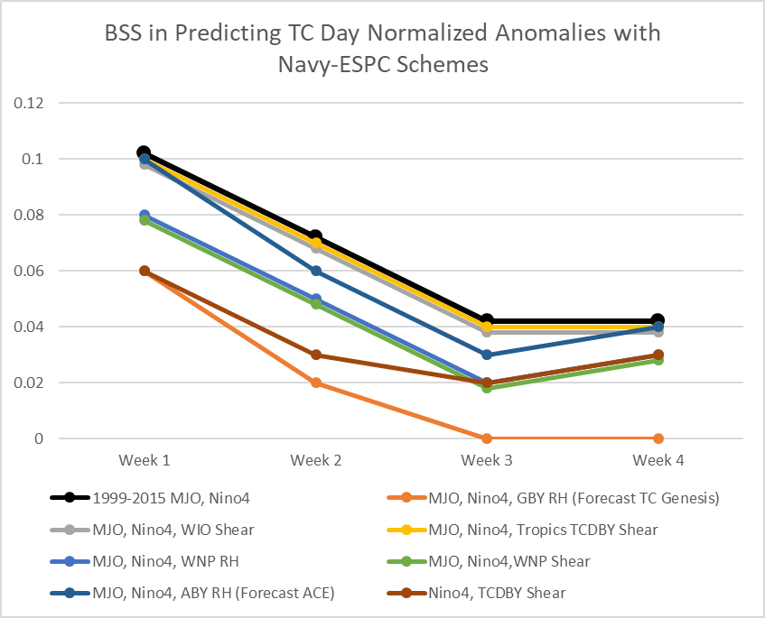
Figure S6. The BSS of various statistical-dynamical schemes using the Navy-ESPC (1999-2015). Predictors included in each scheme are shown in the key below the plot.

