Supplementary information

Computational Modeling of Indoor Organic Photovoltaics: Dataset Curation, Predictive Analysis, and Machine Learning Approaches

Hung-Nien Yuª, Hsu-Yuan Chen^{b}, Ganesh D. Sharma^{c,d}, Yen-Ju Cheng^{e,f}, Chain-Shu Hsu^{e,f}, Ta-Ya Chu^{g}, Jianping Lu^{g}, and Fang-Chung Chen^{a,f,}*

ªDepartment of Photonics, College of Electrical and Computer Engineering, National Yang Ming Chiao Tung University, Hsinchu 30010, Taiwan
^{b}National Chutung Senior High School, Hsinchu 31046, Taiwan
^{c}Department of Physics, The LNM Institute of Information Technology, Jamdoli,
Jaipur, 302031, Rajasthan, India
^{d}Department of Electronics and Communication Engineering, The LNM Institute of
Information Technology, Jamdoli, Jaipur, 302031, Rajasthan, India
^{e}Department of Applied Chemistry, National Yang Ming Chiao Tung University, Hsinchu 30010, Taiwan
^{f}Center for Emergent Functional Matter Science, National Yang Ming Chiao Tung University, Hsinchu 30010, Taiwan
^{g}Advanced Electronics and Photonics Research Centre, National Research Council Canada, Ottawa, Ontario K1A 0R6, Canada

*Corresponding author.
E-mail address: fcchendop@nycu.edu.tw (F. C. Chen)

Data availability
The dataset and python codes in this work can be found on Github:
https://github.com/FC-Richard-Chen/Dataset-indoor-OPVs

Table S1. Hyperparameters for each model.^{a)}
Parameter name | Parameter value | Parameter sampling
SVR
kernel | default rbf
Regularization parameter (C) | 0.1 - 20 | longuniform
Gamma kernel coefficient | 10⁻² - 1 | longuniform/every 0.005
RF
n_estimators | 100, 200, 256
KNN
n_neighbors | 2-10 | integer
ANN (MLP Regressor)
hidden layer sizes | 100, 50, 10 | optimal values
activation | relu, logistic
solver | adam, sgd
learning rate | adaptive
maximum number of iterations | 1000
^{a)}Hyperparameters not included were set as default.

Table S2. Performance of the models trained on the dataset of indoor OPVs in predicting the PCE values.^{a)}
 | SVR | RF | KNN | ANN
Input | Fingerprint + Molecular Orbitals
r | 0.860±0.073 | 0.823±0.123 | 0.734±0.151 | 0.857±0.066
MSE | 16.26±12.77 | 18.45±16.70 | 24.11±15.20 | 16.71±12.74
RMSE | 3.75±1.47 | 3.96±1.66 | 4.67±1.51 | 3.85±1.38
R² | 0.663±0.157 | 0.599±0.232 | 0.473±0.198 | 0.627±0.179
MAPE | 0.187±0.087 | 0.184±0.078 | 0.244±0.111 | 0.208±0.102
^{a)}The MinMaxScaler utility class from scikit-learn was used to perform the scaling.

Table S3. Results of predictions from the ML models for the unseen D/A combinations.^{a)}
D/A Combination  (Experimental PCE)  [%] |  | SVR | RF | KNN | ANN^{b)}
PM6:L8-BO | Prediction | 19.68 | 19.70 | 16.57 | 24.11
(24.17) | Accuracy [%] | 81.4 | 81.5 | 68.6 | 99.8
PM6:PYFO-T | Prediction | 17.59 | 22.67 | 18.1 | 19.84
(19.9) | Accuracy [%] | 88.4 | 87.9 | 91.0 | 99.7
PM6:PYFO-V | Prediction | 17.69 | 20.93 | 18.1 | 18.59
(25.7) | Accuracy [%] | 68.8 | 81.4 | 70.4 | 72.3
PTQ10: tPDI2N-tMeB | Prediction | 13.82 | 17.51 | 14.65 | 12.64
(15.3) | Accuracy [%] | 90.3 | 87.4 | 95.8 | 82.6
PTQ10: tPDI2N- Eada | Prediction | 13.75 | 17.42 | 14.65 | 12.50
(16.7) | Accuracy [%] | 82.3 | 95.9 | 87.8 | 74.9
PM7:DTSiC-4F | Prediction | 14.70 | 16.61 | 17.59 | 16.07
(21.17) | Accuracy [%] | 69.4 | 78.5 | 83.1 | 75.9
PM7:DTSiC-2M | Prediction | 15.89 | 22.08 | 19.10 | 19.92
(19.53) | Accuracy [%] | 81.4 | 88.5 | 97.8 | 98.0
PM7:DTSiCODe-4F | Prediction. | 16.62 | 24.22 | 16.70 | 21.01
(20.14) | Accuracy [%] | 82.5 | 83.2 | 82.9 | 95.9
^{a)}The Models were trained with fingerprints and frontier molecular orbitals.
^{b)}The MinMaxScaler utility class from scikit-learn was used to perform the scaling.

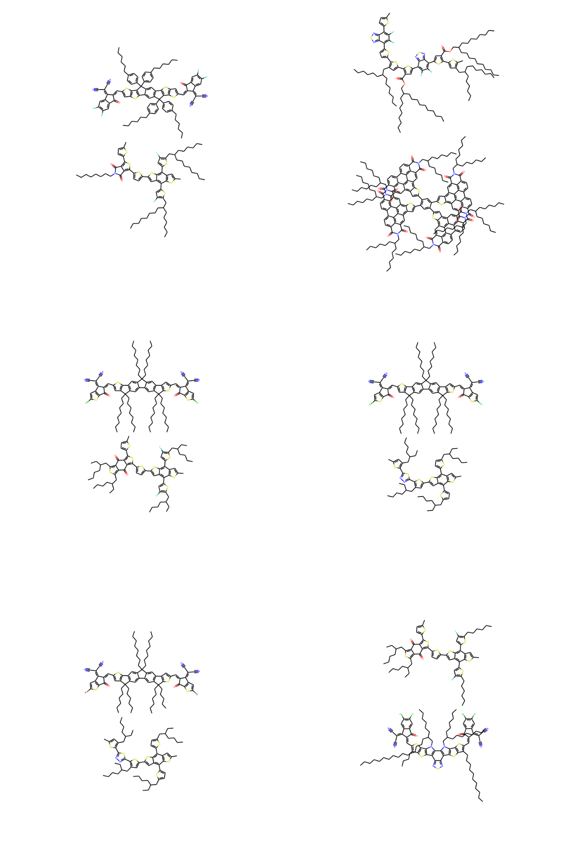Scheme 1. The moelcular structures of the top D/A combinations with the highest PCE values (not in order of PCEs), including TPD-3F:IT-4F, P3TEA:FTTB-PDI4, PM6:FCC-Cl, PB2:FCC-Cl, PB2:FTCC-Br, and PM6:HD-4Cl.

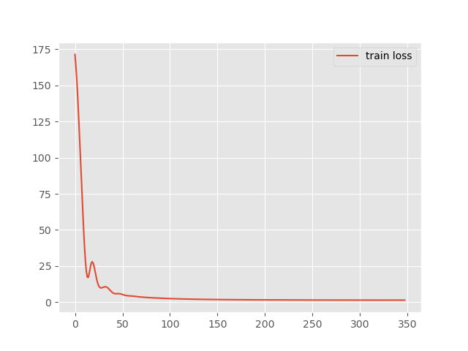
Figure S1. The training loss curve of the ANN model.

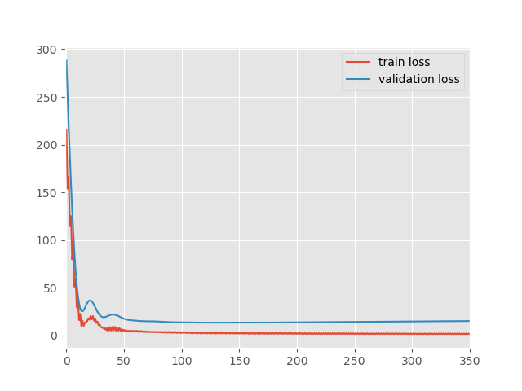

Figure S2. The training and validation loss curves of the ANN model during a separate individual training. Because MLPRegressor in scikit learn does not have the loss function for both training and validation, we plot separately for a separate training process in parallel.

