Supporting Information
Localized Surface Plasmon Resonance Biosensor Chip Surface Modification and Signal Amplifications Toward Rapid and Sensitive Detection of COVID-19 Infections

Xingkai Hao ¹, Jean-Philippe St-Pierre ¹, Shan Zou ², Xudong Cao ¹*

¹ Department of Chemical and Biological Engineering, University of Ottawa, 161 Louis Pasteur, Ottawa, ON K1N 6N5, Canada
² Metrology Research Centre, National Research Council Canada,100 Sussex Drive, Ottawa, Ontario K1A 0R6, Canada

* Corresponding author: Prof. Xudong Cao
Tel.: 613-562-5800 ext. 2047
Fax: 613-562-5172
Email: xcao@eng.uottawa.ca

S1 Materials and Methods
S1.1 Materials
N-hydroxysuccinimide (NHS), 1-ethyl-3-(3-dimethylaminopropyl) carbodiimide hydrochloride (EDC), bis(sulfosuccinimidyl)suberate (BS³), (tris(2-carboxyethyl)phosphine) hydrochloride salt (TCEP-HCl), phi29 DNA polymerase, 10×reaction buffer for phi29 polymerase (containing 330 mM Tris-acetate (pH 7.9), 100 mM magnesium acetate, 660 mM potassium acetate, 1% Tween 20, 10 mM dithiothreitol), T4 DNA ligase, 10×T4 ligation buffer (containing 400 mM Tris-HCl, 100 mM MgCl₂, 100 mM DTT, 5 mM ATP, pH 7.8), deoxynucleotide triphosphate (dNTP) solution mix were purchased from Fisher Scientific (Ottawa, ON). Phosphate-buffered saline (PBS) (0.01 M, pH 7.4), phosphate buffer (PB) (pH=8.0), bovine serum albumin (BSA), hydrogen tetrachooroaurate(Ⅲ)trihydrate (HAuCl₄), trisodium citrate, ethanolamine-HCL solution (1 M, pH 8.5), glycine-HCL buffer (10 mM, pH 2.0), 11-Mercaptoundecanoic acid (11-MUA), gold nanoparticles (100 nm, stabilized suspension in citrate buffer), poly (allylamine hydrochloride) (PAH) (Mw 50,000) and poly(sodium 4-styrenesulfonate) (PSS) (Mw 70,000) were purchased from Sigma-Aldrich (Oakville, ON). Poly(amidoamine) (PAMAM) dendrimer generation 3.5 with carboxyl functional groups (G3.5-COOH) and generation 4 with amino functional groups (G4-NH₂) were purchased from Dendritech (Midland, MI). Pseudo-SARS-CoV-2 and negative viral particles (i.e., viral particles without S protein on the surface) were purchased from MyBiosource (San Diego, CA). Recombinant SARS-CoV-2 spike protein receptor-binding domain (SRBD) and anti-SARS-CoV-2 SRBD antibodies were purchased from FANTIBODY (Chongqing, China). Recombinant MERS-CoV and SARS-CoV SRBD proteins were purchased from ABclonal Science Inc (Woburn, MA). All DNA sequences were custom synthesized by Integrated DNA Technologies (Coralville, IA).

S1.2 Fabrication of Carboxyl Functionalized LSPR Sensor Chips
To fabricate carboxyl functionalized LSPR sensor chips, we employed a well-established approach by alternating depositions of PAH and PSS polymer layers on a glass surface upon which a final layer of gold nanoparticles (diameter=100 nm, ~3.8×10¹⁰ particles/mL in a citrate buffer) was adsorbed (Lu et al. 2021). Subsequently, the resulting surface was treated with an 11-MUA solution to render carboxyl functional groups on the surface of gold nanoparticles. Eight layers each of PAH and PSS were adsorbed on the glass surface and the last layer was PAH.

S2 Characterization
S2.1 Characterization of Carboxyl Functionalized LSPR sensor chip
X-ray Photoelectron Spectroscopy (XPS)
Figure S1 below shows the N 1s and C 1s scan of high-resolution XPS spectra of the carboxyl functionalized LSPR sensor chip surface. For the N 1s scan, the peak at 399.7 eV, strongly indicates -NH₂ functional groups on the sensor chip surface (Min et al. 2012; Strle et al. 2017). For the C 1s scan, the peak was deconvoluted into three peaks, indicating C-C (284.6 eV) (Min et al. 2012; Xu et al. 2011), O-C=O (288.7 eV) (Demirci et al. 2012; Min et al. 2012) and C-N (286.2 eV) (Min et al. 2012; Xu et al. 2011) structures on the sensor chip surface. It should be noted that the C-N (286.2 eV) structure detected by the XPS strongly indicates a surface functionalized with amines (i.e., C-NH₂). The XPS result also confirms the existence of –COOH on the sensor chip surface as evidenced by the presence of O-C=O peak at 288.7 eV.
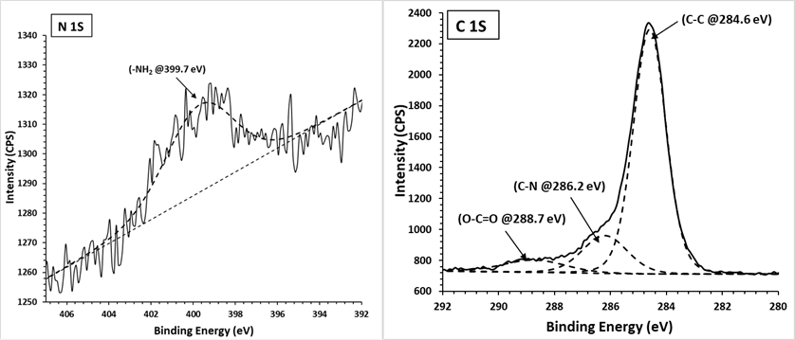
Figure S1. N 1s and C 1s scan of high-resolution XPS spectra of the sensor chip surface (take-off zero degrees). Data analysis was processed using CasaXPS software (v 2.3.19); the fitting residual standard errors (i.e., residual STD) for both N 1s and C 1s scans < 0.9.

S2.2 Characterization of (G3.5+G4)-aptamer Surface Modifications
Fluorescence labeling methods
To follow each surface modification steps, fluorescently labeled molecules (i.e., FITC-G3.5-COOH, rhodamine-G4-NH_{2,} and cy3-aptamer-NH₂) were employed to monitor the success of the surface modifications. The fluorescence intensity changes before and after surface modifications were compared. As shown in Figure S2, fluorescence intensities of the surfaces modified with the fluorescently labeled molecules (see covalent binding groups, the green bars) were significantly higher than those of the control groups (i.e., see the blue bars) and physical adsorption groups (i.e., see the red bars), confirming the success of each step of surface modifications.

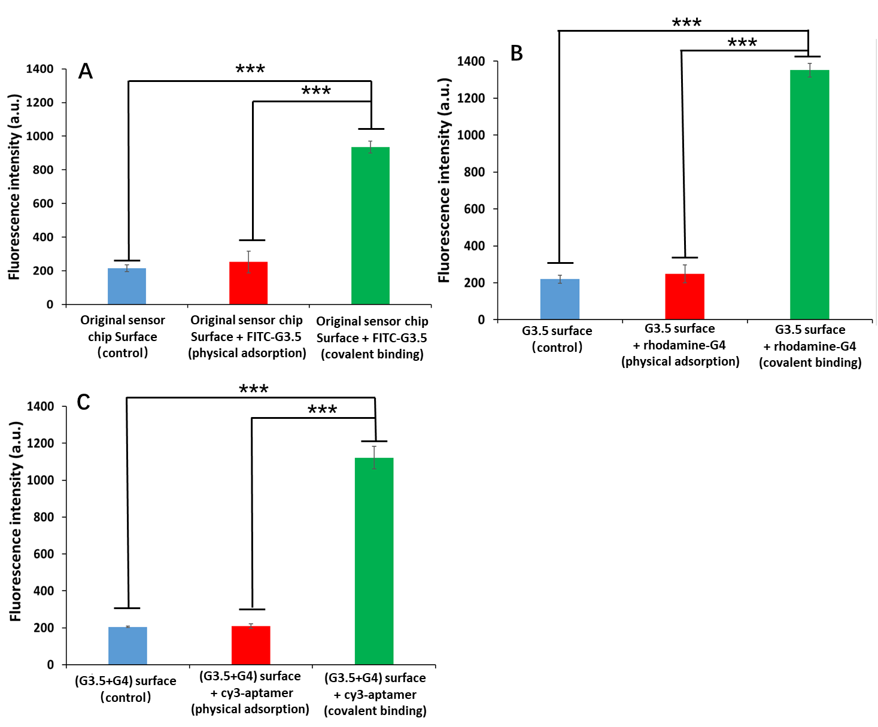
Figure S2. Changes in fluorescence intensities before and after surfaces modification with fluorescence-labeled molecules. A) Fluorescence intensities of original sensor chip surfaces modified by FITC labeled G3.5-COOH molecules (i.e., FITC-G3.5) to confirm the success of G3.5 immobilization. B) Fluorescence intensities of G3.5-COOH modified surfaces modified by rhodamine-labeled G4-NH₂ molecules (i.e., rhodamine-G4) to confirm the success of G4 immobilization. C) Fluorescence intensities of (G3.5+G4) modified surfaces conjugated with cy3-labeled aptamers (i.e., cy3-aptamer) to confirm the success of aptamer conjugation. Error bars indicate standard deviation, n=3. The p values (***<0.001) were calculated by a Student’s t-test, 2 tails.

LSPR signal changes
To further confirm that the surface modification steps were successful, the LSPR signals of each modified layer were compared. As shown in Figure S3, LSPR signals were increased after each step of surface modifications, indicating a surface mass increase of each layer due to the successful immobilization of biomolecules (i.e., G3.5, G4, and aptamers) (Schasfoort 2017). These results strongly suggest that the surface modifications of the LSPR sensor chip were successful.

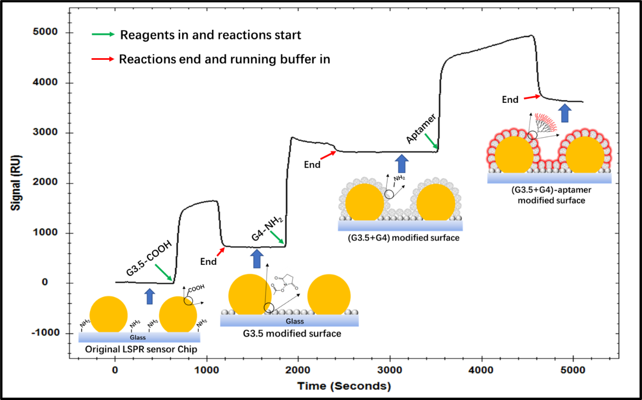
Figure S3. A sensorgraph of each step of surface modifications.

S2.3 Characterization of AuNPs and ssDNA-AuNPs conjugates
Figure S4 shows the characterization results of AuNPs and ssDNA-AuNPs conjugates. The TEM image (Fig S4A) shows that most of the synthesized AuNPs presented homogeneous spherical particles with an average diameter of 15.6±1.0 nm (n=100). The DLS results (Fig S4B) show that the ssDNA-AuNPs conjugates presented a larger particle size than the original AuNPs, indicating that conjugations of ssDNA on the AuNPs were successful. Moreover, the UV-vis spectra (Fig S4C) reveal that in comparison with the AuNPs peaked at 519 nm, the AuNPs-ssDNA presented an ssDNA-specific absorbance peak at 260 nm and showed a 6 nm redshift peaked at 525 nm. These observations further suggested that the AuNPs were successfully conjugated with ssDNA probes (He et al. 2014). In addition, the changes in the fluorescence intensities (Fig S4D) were another strong evidence confirming that conjugations of AuNPs with ssDNA probes were successful, as the fluorescence intensity of the fluorescently labeled ssDNA-AuNPs conjugates (i.e., FAM-ssDNA-AuNPs) was 87-time higher than those of AuNPs and non-fluorescence labeled ssDNA-AuNPs conjugates (i.e., ssDNA-AuNPs).

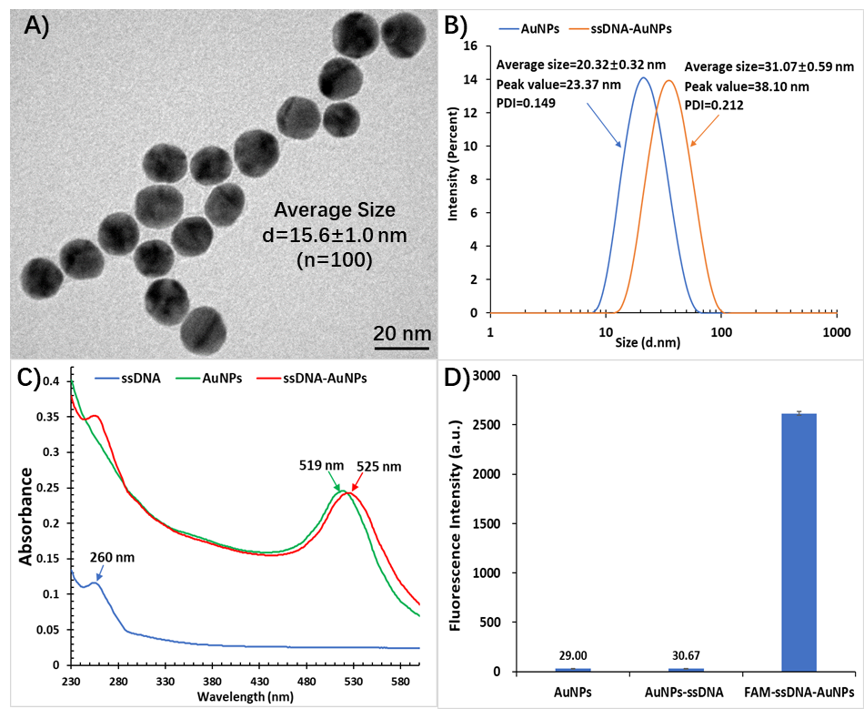
Figure S4. Characterization of AuNPs and ssDNA-AuNPs conjugates. A) A transmission electron microscopic image of AuNPs; B) particle size analysis of AuNPs and ssDNA-AuNPs conjugates using dynamic light scattering (DLS) method; C) ultraviolet-visible spectrum changes between samples of ssDNA, AuNPs, and ssDNA-AuNPs conjugates; D) fluorescence intensities changes between samples of AuNPs, ssDNA-AuNPs and ssDNA-AuNPs labeled with FAM (i.e., FAM-ssDNA-AuNPs); error bars indicate standard deviation, n=3.

S2.4 Characterization of RCA products
To characterize RCA products, a native polyacrylamide gel (8%) electrophoresis (PAGE) was employed. As shown in Figure S5, the primer and padlock probe showed distinct bands around 20 and 45 bp, respectively; after hybridization, the band of the hybridized products moved to around 65 bp. It is interesting to note that the RCA products showed extremely low mobility, as it was trapped in the well of the gel apparatus due to high molecule weight, strongly suggesting the success of the RCA reaction.
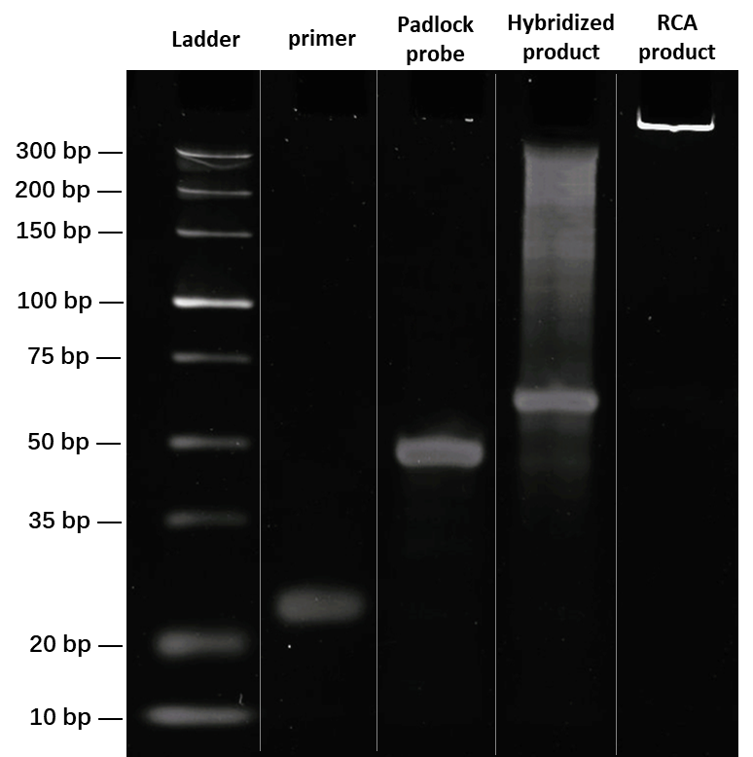
Figure S5. A gel electrophoresis image of RCA product.

S3 Optimization of buffer conditions and flow rate
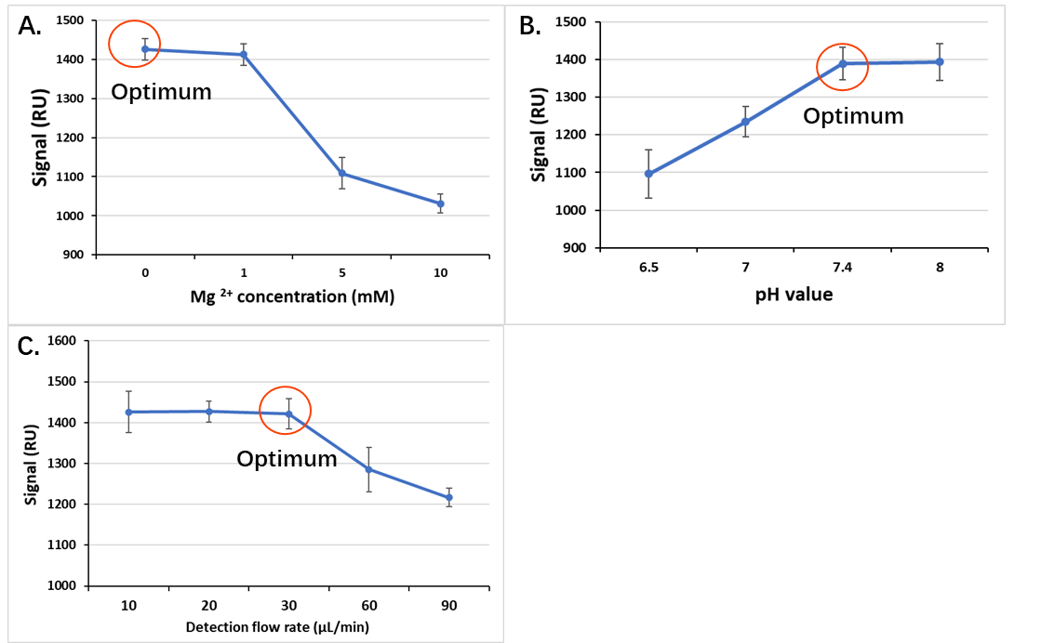
Figure S6. Optimization of buffer conditions and flow rate for (G3.5+G4)-aptamer sensor chips. A) influence of Mg ²⁺ concentration on detection signals, B) influence of pH value on detection signals, and C) influence of flow rate on detection signals.

S4. Regeneration tests.
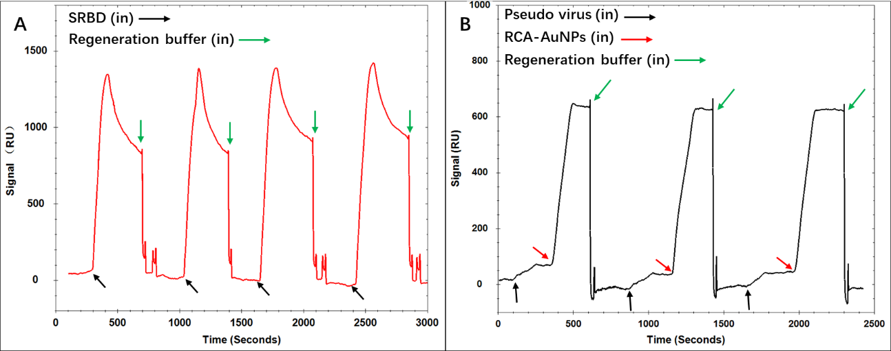
Figure S7. Regeneration test of the (G3.5+G4)-aptamer sensor chips for SRBD (A) and pseudovirus (B) detections. Note that the sensor chips can be regenerated multiple times using the regeneration buffer (i.e., glycine-HCL (10 mM, pH 2.0)).

S5 Calculation Ratio of Surface Aptamer Concentration vs. Surface Antibody Concentration
The ratio of surface aptamer concentration vs. surface antibody concentration can be calculated using the following equations (De Feijter et al. 1978; Hand 1935; Unser et al. 2015)
$R=m∆n[1-\exp\left(\frac{-2d}{l_{d}}\right)]$ (1); $∆n=C(d_{n}/d_{c})$ (2)
where R is the sensor response to an attached layer, m is the refractive index sensitivity, d is the thickness of the attached layer, l_{d} is the electromagnetic field decay length, ∆n is the difference in refractive index between the attached layer and the surrounding medium, C is material concentration in the attached layer, and d_{n}/d_{c} is the refractive-index increment.

In our case, we tested the surface signal R _{antibody}=2325 and R_{G4}=2017; the l_{d} value is estimated to be 20 nm based on published results (Haes et al. 2004; Jain et al. 2007), and m is a constant provided by the producer; the d_{antibody} =7.1 nm (Dong and Shannon 2000), d_{G4} =1.8 nm (Eichman et al. 2000), d_{n}/d_{c} value of antibodies is 0.185 cm³/g (Longman et al. 2006), and d_{n}/d_{c} value of G4 is 0.200 cm³/g (Yanez Arteta et al. 2014) based on the reported data. We assume that our modified surfaces are homogeneous without molecule distortion so that we can calculate the ratio of surface G4 concentration vs. surface antibody concentration.
Therefore, C_{G4}/C_{antibody}=1.24
Moreover, one G4 molecule can conjugate with 44 aptamers in solution conditions tested by conjugating fluorescence-labeled aptamers with G4 molecules (see the following experimental data for more details). Assuming that the conjugation rate is around 30%-80% when aptamers conjugate with G4 on the LSPR surface, the estimated ratio of surface aptamer concentration vs. surface antibody concentration is around 16-44.

The number of aptamers conjugated on each G4 molecule.
To estimate the number of the aptamers conjugated to each G4 molecule, amino-capped aptamers with fluorescence tags (i.e., NH₂-aptamer-cy3) were employed to conjugate with G4 molecules in a solution condition. Specifically, a reaction mixture containing 200 µM NH₂-aptamer-cy3, 1 nM G4, and 20 mM BS³ in PBS (pH 7.4) was reacted at room temperature for 20 min. Subsequently, the resulting mixture was filtered using an Amicon Ultra centrifugal filter (molecular weight cutoff = 50 KDa) to remove the unconjugated aptamers (Mw < 50 KDa) and to purify the resulting G4-aptamer conjugates (Mw > 50 KDa). Subsequently, the purified G4-aptamer conjugates were used to calculate the concentration of fluorescent aptamers conjugated to the G4 molecules against a calibration curve established using known concentrations of NH₂-aptamer-cy3. The number of aptamers on each G4 molecule was calculated using the equation below:
Number of aptamers on each G4 molecule= $\frac{Concentration of the quantified aptamers}{Concentration of G4 molecules }$ .

As shown in Figure S8, the concentration of aptamers conjugated on G4 molecules was calculated as 43.6 nM, and the concentration of G4 molecules in the reaction was 1 nM. Therefore, the number of aptamers on each G4 molecule was determined to be 44.
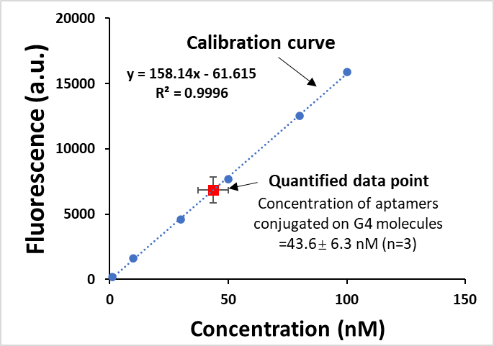
Figure S8. Quantification of concentration of aptamers conjugated on G4 molecules.

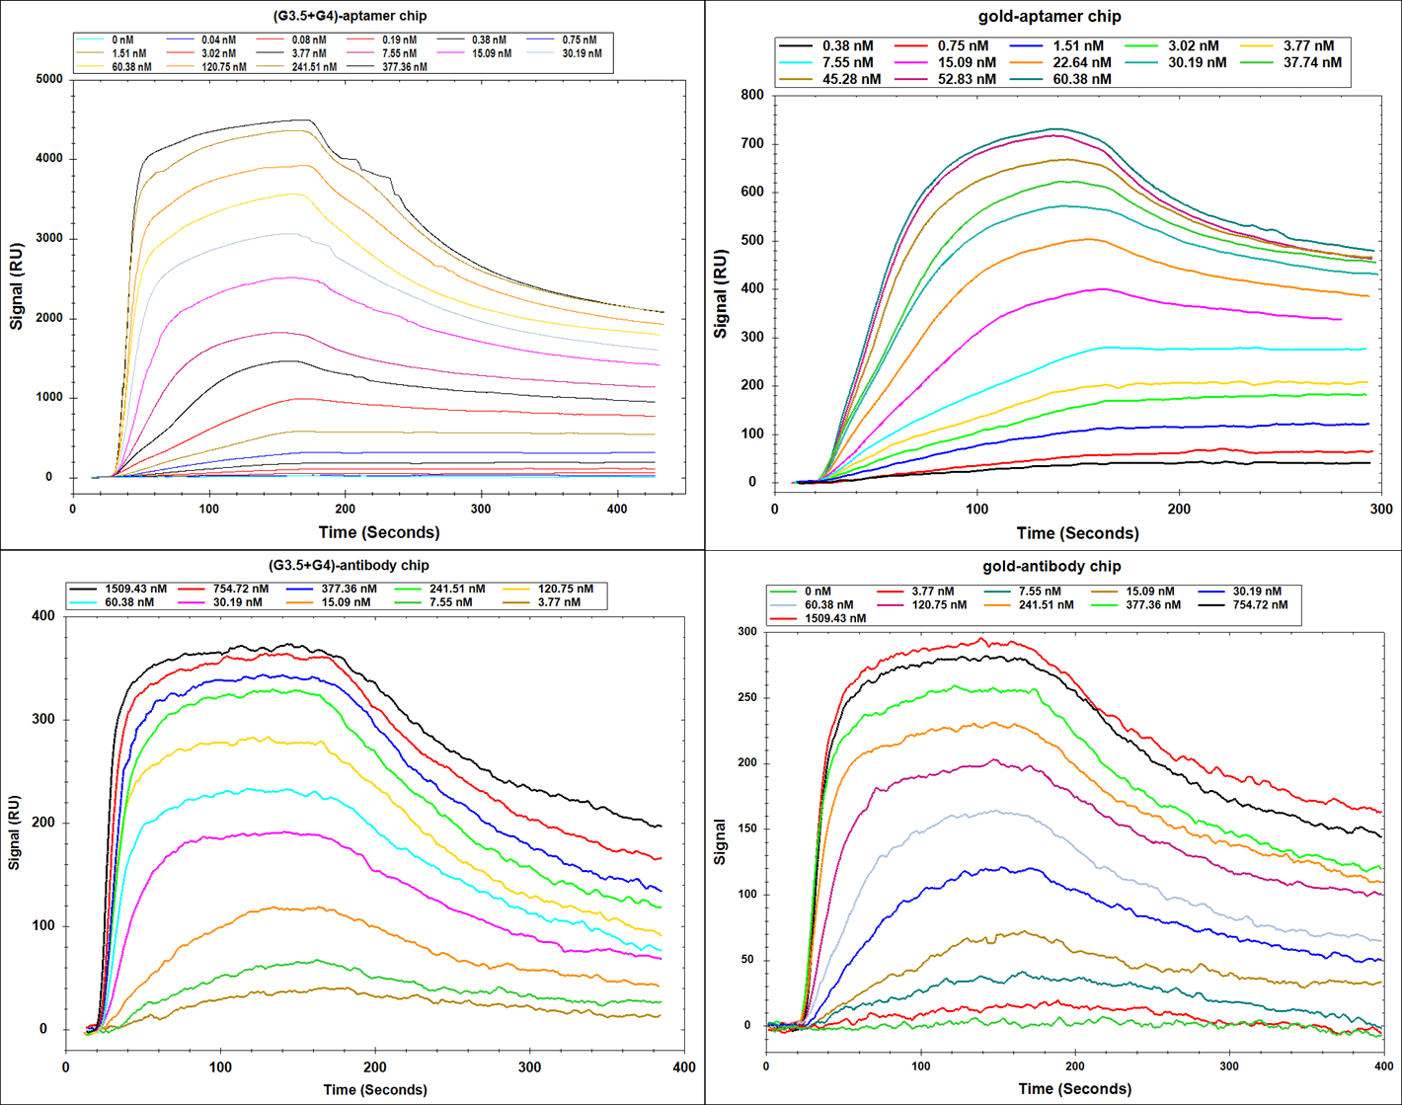
S6. LSPR Sensorgraphs of Different Modified Sensor Chips for SRBD Detection
Figure S9. LSPR sensorgraphs of sensor chips with different surface modifications for SRBD detection. Response signals were collected at 165 s for creating response curves in Figure 3.

References
De Feijter, J., Benjamins, d.J., Veer, F., 1978. Biopolymers: Original Research on Biomolecules 17(7), 1759-1772.
Demirci, S., Emre, F.B., Ekiz, F., Oğuzkaya, F., Timur, S., Tanyeli, C., Toppare, L., 2012. Analyst 137(18), 4254-4261.
Dong, Y., Shannon, C., 2000. Analytical Chemistry 72(11), 2371-2376.
Eichman, J.D., Bielinska, A.U., Kukowska-Latallo, J.F., Baker, J.R., 2000. Pharmaceutical Science & Technology Today 3(7), 232-245.
Haes, A.J., Zou, S., Schatz, G.C., Van Duyne, R.P., 2004. The Journal of Physical Chemistry B 108(1), 109-116.
Hand, D.B., 1935. Journal of Biological Chemistry 108(3), 703-707.
He, P., Liu, L., Qiao, W., Zhang, S., 2014. Chemical Communications 50(12), 1481-1484.
Jain, P.K., Huang, W., El-Sayed, M.A., 2007. Nano Letters 7(7), 2080-2088.
Longman, E., Harding, S.E., Marheineke, N., 2006. LC GC North America 24(1), 64.
Lu, M., Peng, W., Lin, M., Wang, F., Zhang, Y., 2021. Nanomaterials 11(3), 616.
Min, H., Girard-Lauriault, P.-L., Gross, T., Lippitz, A., Dietrich, P., Unger, W.E.S., 2012. Analytical and Bioanalytical Chemistry 403(2), 613-623.
Schasfoort, R.B.M., 2017. Introduction to Surface Plasmon Resonance, in: Schasfoort, R.B.M. (Ed.), Handbook of Surface Plasmon Resonance. The Royal Society of Chemistry, pp. 1-26.
Strle, D., Štefane, B., Trifkovič, M., Van Miden, M., Kvasić, I., Zupanič, E., Muševič, I., 2017. Sensors 17(12), 2845.
Unser, S., Bruzas, I., He, J., Sagle, L., 2015. Sensors 15(7), 15684-15716.
Xu, Z.X., Li, T., Zhong, Z.M., Zha, D.S., Wu, S.H., Liu, F.Q., Xiao, W.D., Jiang, X.R., Zhang, X.X., Chen, J.T., 2011. Biopolymers 95(10), 682-694.
Yanez Arteta, M., Ainalem, M.-L., Porcar, L., Martel, A., Coker, H., Lundberg, D., Chang, D.P., Soltwedel, O., Barker, R., Nylander, T., 2014. The journal of physical chemistry B 118(45), 12892-12906.

