Quantifying UVC-Induced Aging of Microplastics Using a Multivariate Aging Score
Yingshu Leng ^{1,2}, Daniel Prezgot ¹, Zygmunt J. Jakubek ¹, Xudong Cao ^{2,3}, Shan Zou ¹*

¹ Metrology Research Centre, National Research Council Canada, 100 Sussex Drive, Ottawa, Ontario K1A 0R6, Canada
² Ottawa–Carleton Institute for Biomedical Engineering, University of Ottawa, 161 Louis Pasteur, Ottawa, Ontario K1N 6N5, Canada
³ Department of Chemical and Biological Engineering, University of Ottawa, 161 Louis Pasteur, Ottawa, Ontario K1N 6N5, Canada

Corresponding Author
*Dr. Shan Zou, Phone: 1-613-949-9675, Email: Shan.Zou@nrc-cnrc.gc.ca (ORCID: 0000-0002-2480-6821)

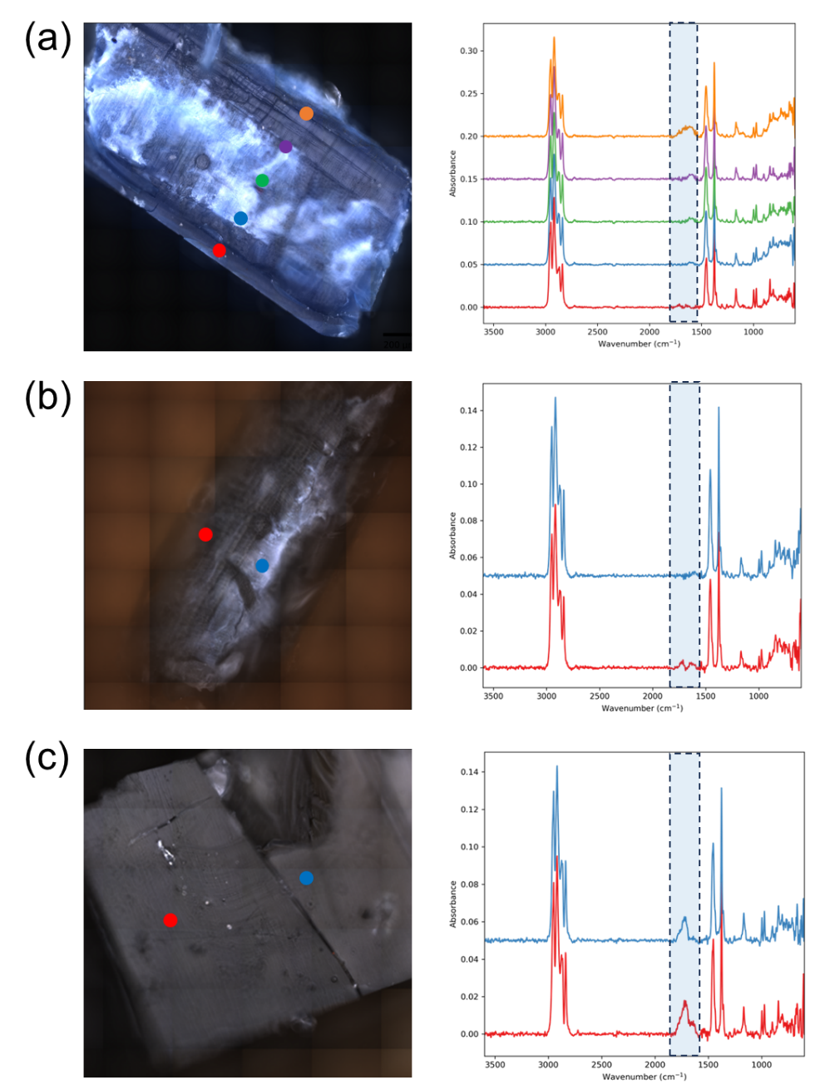
Fig. S1 Optical images of PP materials cross sections and ATR-FTIR spectra collected at selected positions. (a) PPPB-L interior cross-section with five sampling points from the interior toward the UVC-exposed surface (red = point near the bottom face in contact with the bottle, orange = point near the directly exposed outer surface). (b) PPCT-L interior cross-section with two randomly selected points (red and blue). (c) PPCT-L exterior surface exposed to UVC, with two randomly selected surface points (red and blue). Colored points in the optical images correspond to the ATR-FTIR spectra of same color in the right panels. These points indicate the sampling locations and do not represent the actual spatial extent of the ATR measurement. The blue dashed box highlights the carbonyl band region
Fig. S2 MDSC thermograms of (a) PPCT and (b) PPPB in large (L), medium (M), and small (S) size fractions at selected UVC exposures of 0, 38, and 60 MJ/m²
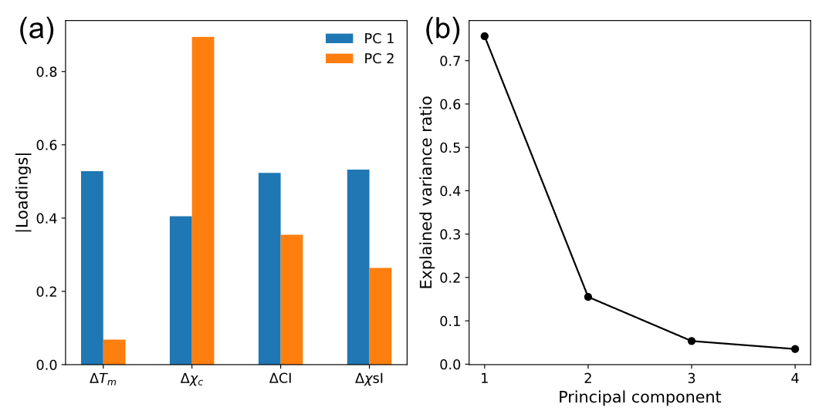
Fig. S3 (a) The loadings of the first 2 principal components (PC), demonstrating the contribution of each feature to the PC. PC1 is influenced by all features, but χc contributes the least, primarily contributing to PC 2. (b) Scree plot of the PCA, demonstrating the explained variance with respect to each principal component. The PC 1 explains ~75% of the variance, followed by ~15% for PC 2. PC’s 3 and 4 explain <10% of the variance, and have minimal impact.
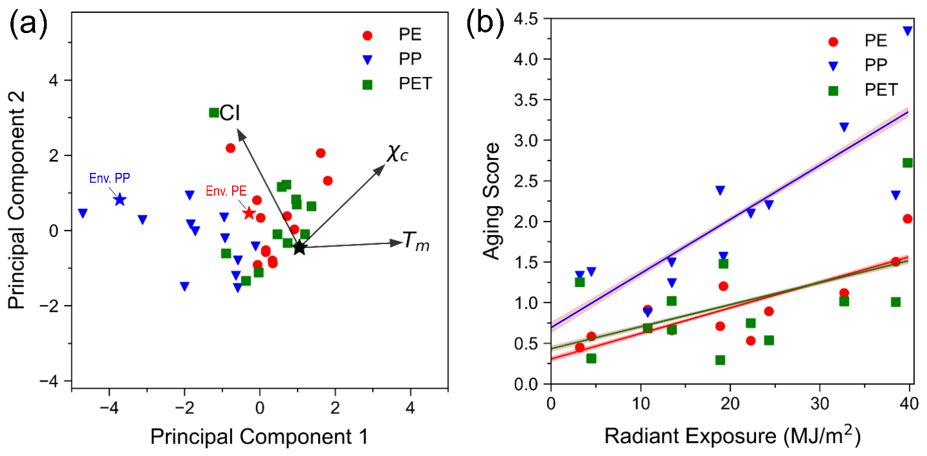
Fig. S4 (a) Principal component analysis of commercial microplastic powders of PE, PP, and PET. The degree of change in each measurement can be used to establish an aging score across different polymers. The red and blue points marked with stars represent environmental samples of PE and PP respectively, showing that their degree of change is consistent with the artificially aged samples. (b) Aging score fitted for each plastic. The aging rate of PP was found to be much larger than that of PE and PET.

