- Supplementary discussion and data for “Size-dependent mass absorption cross section of soot from various sources”
This supplementary information contains supplementary information for http://dx.doi.org/10.1016/j.carbon.2022.02.037:
- Additional text on data analysis
- Additional tables from our literature review of MAC measurements
- Additional visualizations of our analysis and results

  - Additional details on average UDAC-CPMA single-particle mass calculation
The conceptual basis for the average UDAC-CPMA single-particle mass calculations was outlined in Section 2.6. Here we provide some additional discussion of both approaches.

The iterative-average-charge (IAC) approach (Figure 2a) estimated the average single-particle mass classified by the CPMA, $\overline{m_{p}}$ or simply $m_{p},$ by iteratively solving

 | $$\overline{m_{p,k+1}}=\overline{m_{p,k}}×\overline{q}=\overline{m_{p,k}}×q_{F}\left(d_{C}\left[\overline{m_{p,k}}\right]\right)$$ | S1

Where $\overline{m_{p,k}}$ and $\overline{m_{p,k+1}}$ are initial and improved estimates of $m_{p}$ and $\overline{q}$ is the average charge for a particle of mass $\overline{m_{p,k}}$ predicted using the Fuchs charging model [60]. The Fuchs model requires a diameter rather than a mass as input; this charging diameter $d_{C}$ was assumed to be equivalent to $d_{m}$, with $d_{m}$ estimated from $\overline{m_{p,k}}$ using the effective density as described in Section 2.6. The initial guesss of $\overline{m_{p,k}}$ is estimated from the CPMA setpoint m/q by assuming q=1, and the equation is iterated until the solution converges.

Under our conditions, results of the Fuchs charging model were adequately represented by a curve with the parameterization of
 | $$\overline{q}=6.4168⋅m_{p}^{0.4204}+0.4587$$ | S2
Where $\overline{q}$ is the average number of charges on a particle of mass $m_{p}$ (in fg) charged by the UDAC at an ion·charge product of ${10}^{13}$ ions·s/m³. This parameterization is useful given the computational complexity of the Fuchs charging model.

The mass-and-charge distribution approach (Figure 2b) was based on the mass distribution of the classified particles estimated by the CPMA transfer function as follows. For each soot source, we represented the particle population using lognormal input distributions in mobility diameter $d_{m}$ ($dN/dlogd_{m}$). These distributions were described by the measured geometric count mean diameters CMD and geometric standard deviations GSD of each source (Table 1). The charge distribution $q(d_{m})$ on these particles after the UDAC, at integer multiples of $m/q$, was predicted using the Fuchs model [60] using a dielectric constant $κ$ of 13.5. This dielectric constant is an average of the range used by Ouf and Sillon [70] for soot, and our results were relatively insensitive to this assumption. The lognormal distributions were then converted to mass distributions ($dN_{in}/dlogm_{p}$) based on Equation 7. The transport of this mass distribution through the CPMA was predicted using a CPMA transfer function calculated for particles with $q=1, 2, 3, …$ for all cases where $dN_{in}/dlogm_{p}$ was substantially greater than zero. The CPMA transfer functions were calculated using the finite-difference method outlined by Sipkens et al. [57]. The overall CPMA output mass distribution $dN_{out}/dlogm_{p}$ was then calculated by combining the input mass distribution wth the charge distribution and transfer function. This calculation assumes that the charge distribution is approximately constant across the narrow width of the CPMA transfer function for each particle charge state.

The $dN_{out}/dlogm_{p}$ predicted by the mass-and-charge distribution approach can be used to estimate $m_{p}$ directly. Since $m_{p}$ is the average mass of the classified particles, its value is

 | $$m_{p}=\frac{1}{N_{out}}\sum_{j}{m_{j}⋅{dN}_{out,j}}$$ | S3

Where ${dN}_{out,j}$ $and$ $m_{j}$ are the number and single-particle mass of particles with classified by the CPMA, respectively. These quantities are summed for all bins in the $m_{p}$ distribution (i.e. integrated over single-particle mass). We then attributed the MAC calculated with Equation 1 (main manuscript) to particles of mass $m_{p}$. This average-mass approach, implicitly assumes that the mass distribution of the CPMA classified particles is narrow (such that most of the particles contributing to $m_{p}$ have similar mass) and that the MAC of the individual particles is constant over this narrow distribution.
As mentioned in Section 2.6. , we also used the $dN_{out}/dlogm_{p}$ predictions to consider the possibility that particles of different $m_{p}$ and therefore different MAC were transmitted by the CPMA at a single setpoint. To this end, we used Equation 1 to describe each unique particle mass $m_{j}$ as having its own MAC, ${MAC}_{mj}$ and its own mass loading $M_{PM,j}=N_{j}m_{j}$:

 | $${MAC}_{m_{j}}=\frac{B_{abn,j}}{N_{j}m_{j}}$$ | S4

Where $N_{j}$ is the total number concentration of particles with mass $m_{j}$ and charge j. Note that a particle with mass $m_{j}$ might be transmitted by the CPMA as a singly charged particle, doubly charged particle, or other multiply charged particle$\left(m_{j}=m_{1}/1=2m_{2}/2=qm_{3}/q\right)$. This fact can be captured using a system of equations and simultaneously solved to determine ${MAC}_{q}$ for all $m_{q}$.

In order to construct a system of equations that is over-constrained (more measurement points than degrees of freedom), we first consolidated the mass fractions of the CPMA classified particles ($f{}_{i,j}=n_{i,j}m_{j}/\sum_{j}{n_{i,j}m_{j}}$) into a matrix of common mass bins (columns) for all test points (rows), then consolidated this matrix into a number of log-spaced mass bins that was a factor of 2 to 4 smaller than the number of test points. The consolidated matrix was further simplified by (a) removing mass bins (i.e. columns of matrix) that were often empty (i.e. $f{}_{i,j}>0.01$ in fewer than three bins at a given value of $j$) and (b) by removing test points where the mass distribution was no longer adequately represented (i.e. $\sum_{j}{f{}_{i,j}}<0.99$) after this consolidation process. The second criteria was rarely implemented and was mostly applied to samples that had multiple mass bins removed for not meeting criterion (a) due to not overlapping in the mass domain of at least two other samples.

The consolidated matrix can be written by defining $f_{i,j}$ as the mass fraction of particles with mass $m_{j}$ at test point $i$ as:

 | $$\left[\begin{matrix}f_{1,1} & ⋯ & f_{1,j} \\ ⋮ & ⋱ & ⋮ \\ f_{i,1} & ⋯ & f_{i,j}\end{matrix}\right]\left[\begin{matrix}{MAC}_{m_{1}} \\ ⋮ \\ {MAC}_{m_{j}} \end{matrix}\right]=\left[\begin{matrix}{MAC}_{1} \\ ⋮ \\ {MAC}_{i} \end{matrix}\right]$$ | S5

which is a system of equations that represents the measured MAC_{i} as a sum of the (potentially) different ${MAC}_{m_{j}}$ for each single-particle mass bin $m_{j}$. This system of equations was solved by applying least-squares minimization inversely weighted by the standard deviation of the average measured MAC at each test point plus 1% of the average measured MAC. The 1% offset was included in the fit normalization to reduce the preferential weighting that least-squares minimization inherently places on the largest values measured and follows previous recommendations [71]. This second method based on the estimated mass distribution is referred to as the system-of-equations approach, and its uncertainties for a k=1 coverage factor were determined by bootstrapping (repeatedly and randomly sampling a subset of the complete data set).
  - Validation of iterative-average-charge (IAC) approach to $m_{p}$

As mentioned in Section 2.6. , we also used the $dN_{out}/dlogm_{p}$ predicted by the mass-and-charge distribution approach (Figure 2b, Section 2.6. , and preceding SI subsection) to validate the simpler IAC algorithm by calculating the relative number of particles of each charge state $q$ exiting the CPMA at a given setpoint.

Figure S2 shows that the three different approaches produce similar results (iterative average charge, average single-particle mass or system-of-equations approaches). The figure uses data from the CAPS PM_{SSA} monitor measuring MISG soot as an example.

The IAC approach agreed closely with the average-single-particle-mass approach for all test points, despite its implicit assumptions that the sampled particle size distribution and the CPMA transfer function may be neglected. This unexpected agreement can be understood by reference to the more detailed calculation of the $m_{p}$ and charge distribution exiting the UDAC–CPMA. The distribution of total charge as a function of $m_{p}$ was approximately lognormal (Figure S1 and Figure S3) due to the large number of charges per particle imparted by the unipolar charger in the UDAC. Our observed agreement implies that this charge distribution played the major role in determining the average $m_{p}$, while the sampled particle size distribution and CPMA transfer function played minor roles. At present, this conclusion is specific to the conditions of our study; further investigation is required to validate these implications and identify limitations of the IAC approach.

Finally, the system-of-equations approach showed a similar trend as the average-single-particle-mass approach in Figure S2. This agreement confirms that the average-mass approach, and its associated assumptions (as previously described) were valid for the data collected in this study. In the following discussion, we focus on the results produced by the average-mass approach because the system-of-equations approach involved grouping the data in the $m_{p}$ dimension in order produce an over-constrained system where the system-of-equations could be fitted successfully.

  - Uncertainty in iterative-average-charge (IAC) approach
The preceding subsection showed that the assumptions behind the IAC approach (Figure 2a) impart minor uncertainty to the result, compared to a complete calculation considering aerosol mass and charge distributions (Figure S2). In this section, we discuss two types of uncertainties which remain in the approach.

The first uncertainty is due to the propagation of uncertainties through the mass-mobility relationship (Equation 6 and 7 in the manuscript). We quantified this uncertainty by a perturbation analysis whereby the inputs to the mass-mobility relationship were perturbed systematically (Table S3). Two of these, $ρ_{eff,100}$ and $ε$ originate in the effective density power law (mathematically equivalent to the mass-mobility relationship) while the third, $n_{i}t$, originates in the UDAC setpoint. For simplicity, we omitted a perturbation of the dielectric constant because it is a multiplicative factor in predicting $q$ [72], so would have the same effect as perturbing $n_{i}t$. As expected from an inspection of Equation 6 or 7, Table S3 shows that the predicted $m_{p}$ is most sensitive to the mass-mobility exponent $ε$, with a $± 5\%$ change in $ε$ leading to a $+39\%$/$-24\%$ change in $m_{p}$ at the extreme upper condition of $m_{p}=10$ fg ($d_{m}≈500$ nm). At the more moderate condition of $m_{p}=1$ fg, a $±5\%$ change in $ε$ leads to a $+18\%/-13\%$ change in $m_{p}$.

The second uncertainty is due to uncertainty in particle morphology. Particle morphology affects the mass-mobility relationship. In the most extreme case, open DLCA aggregate structures ($ε=2.48$) become quasi-spherical ($ε≈3$, a $+17\%$ change) after the condensation of volatile materials. A correlated change in ρ_{eff,100} is expected and must be considered. Considering the extreme case of highly-compact particles based on measurements made in our laboratory (for which $ε=2.97$ and $ρ_{eff,100}=411.35$ according to a fit to Equation 6; where the value of $ε$ close to 3 indicates near sphericity), we calculated a difference in $m_{p}$ of 11% and 39% at $110$ nm and 240 nm respectively. In other words, when soot particles are assumed to be DLCA aggregates, their true mass may be 39% higher at 240 nm than predicted. This corresponds to a shift by a factor of 1.39 on the abscissas of Figure 3, Figure 4, and Figure 5, which is negligible considering the two orders of magnitude spanned by those axes.

Morphology also affects particle charging. For particles of $d_{m}=$ 100 nm, agglomerates charged by unipolar diffusion chargers have $<20\%$ more charge-per-particle than spheres of the same $d_{m}$ [59,72]. A more precise quantification of this charging uncertainty is difficult due to the complexity of charging models, as well as the difficulty of obtaining reliable reference data [73]. Regardless, this charging uncertainty is smaller than the morphology-related uncertainty in the mass-mobility relationship.

  - Fit function applied to size-dependent MACs
In Figure 4 and Figure 5, we used the error function to describe our MAC observations, with lower limit a, upper limit b, and abscissa-offset and scaling parameters c and d:
 | $$MAC=a+\left(b-a\right)\left[\frac{1}{2}+\frac{1}{2}\operatorname{erf}\left(c\log{m_{p}}-d\right)\right]$$ | S6

We hypothesize that $a≈4 m^{2}g^{-1}$ (the MAC of incipient soot particles described by Wan et al. [36]), $b≈8±0.7 m^{2}g^{-1}$ (the MAC of mature soot reviewed by Liu et al. [16]) and that $c$ and $d$ vary slightly according to the discussion in the main text. However, the available data did not allow this hypothesis to be rigorously tested and all reported fits were performed without constraint.
  - Single-scattering albedo (SSA)

Our CAPS PM_{SSA} measurements provide single-scattering albedos (SSAs) at 660 nm for each size-resolved MAC test point. Figure S8 and Figure S9 show these SSAs plotted as a function of average single-particle mass $m_{p}$ and as a function of MAC, respectively. In Figure S8, the SSA generally increases slightly from 0.12 to 0.22 as $m_{p}$ increases from 0.3 fg to 10 fg. The SSA trend is not clearly sigmoidal as was the case for MAC, potentially because the SSA is influenced more strongly by morphology than the MAC [18,20]. Also, the SSA trend shows less source-to-source variability than the corresponding trend of MAC versus $m_{p}$ (as discussed in the main text), potentially because the SSA trend reflects increasing particle size parameter $x$ rather than a changing MAC [17]. Notably, the trend for the Argonaut MISG and the diesel engine soot indicate higher SSAs for larger particles than the other sources. This may reflect more-compact soot particles being emitted from these sources relative to the others.

In Figure S9, the 660 nm SSA is plotted against the MAC reported in the manuscript. No clear trend is seen in the data. The SSA was more strongly associated with particle size than with the measured MAC.

- Supplementary References

[71] F.-X. Ouf, P. Sillon, Charging Efficiency of the Electrical Low Pressure Impactor’s Corona Charger: Influence of the Fractal Morphology of Nanoparticle Aggregates and Uncertainty Analysis of Experimental Results, Aerosol Sci. Technol. 43 (2009) 685–698. https://doi.org/10.1080/02786820902878245.

[72] M.D. Wilson, D.M. Rocke, B. Durbin, H.D. Kahn, Detection limits and goodness-of-fit measures for the two-component model of chemical analytical error, Anal. Chim. Acta. 509 (2004) 197–208. https://doi.org/10.1016/j.aca.2003.12.047.

[73] L.N.Y. Cao, J. Wang, H. Fissan, S.E. Pratsinis, M.L. Eggersdorfer, D.Y.H. Pui, The capacitance and charge of agglomerated nanoparticles during sintering, J. Aerosol Sci. 83 (2015) 1–11. https://doi.org/10.1016/j.jaerosci.2015.01.002.

[74] T.J. Johnson, R.T. Nishida, X. Zhang, J.P.R. Symonds, J.S. Olfert, A.M. Boies, Generating an aerosol of homogeneous, non-spherical particles and measuring their bipolar charge distribution, J. Aerosol Sci. 153 (2021) 105705. https://doi.org/10.1016/j.jaerosci.2020.105705.

- Supplementary tables
Table S1. Instruments used to measure in situ aerosol light absorption in this work. CAPS PM_{SSA}: Cavity attenuation phase shift—particulate matter single scattering albedo; MSS: Micro soot sensor plus; PAX: photoacoustic extinctiometer.

Instrument | $λ$ [nm] | Measurement principle | Calibration source
CAPS PM_{SSA} | 660 | Extinction minus scattering | (NH₄)₂SO₄
MSS | 808 | Photoacoustic | MISG soot
PAX | 870 | Photoacoustic | Graphitic nanoparticles and (NH₄)₂SO₄

Table S2. Experimental conditions of single-particle-mass- or size-resolved MAC measurements in the literature. The APM (Aerosol Particle Mass Analyzer) in this table is analogous to the CPMA. The expression “DMA–APM+CPC” (or “DMA-CPMA+CPA”) describes the use of a DMA to size-classify particles that are then counted by a CPC, then multiplied by the average single-particle mass measured by an APM–CPC (or CPMA-CPC) experiment, which is sometimes called an effective density measurement.
Study | Particle charging | Particle classification | Absorption measurement, B_{abn} | Mass concentration measurement, M_{PM} | Multiple charging addressed by
This work | Highly charged (UDAC) | CPMA | Photoacoustic (2 instruments) and extinction-minus-scattering  (CAPS PM_{SSA}) | CPMA–electrometer | Average single-particle mass from UDAC-CPMA; checked against downstream SMPS measurement
Khalizov 2009 [26] | Equilibrium (²¹⁰Po) | DMA–DMA | Extinction-minus-scattering  (house-made) | DMA–APM+CPC | Treated as negligible after two charger-DMAs
Dastanpour 2017 [24] | Highly charged (UDAC) | CPMA | Extinction-minus-scattering  (CAPS PM_{SSA}) | CPMA–electrometer | Reference to downstream SMPS measurement
Forestieri 2018 [25] | Equilibrium  (X-ray) | DMA and DMA–CPMA | Photoacoustic (3 instruments) and extinction-minus-scattering  (CAPS PM_{SSA}) | DMA–CPMA+CPC | Measurement of multiple charges by SMPS or single-particle soot photometer
Kholghy and DeRosa 2020 [27] | Equilibrium  (X-ray) | DMA | Photoacoustic (DMT PAX) | DMA–APM+CPC | Treated as negligible after one charger-DMA

Table S3. Sensitivity of the iterative-average-charge calculation to the input parameters. The third column shows the change in $m_{p}$ following a perturbation of the input parameters by 5%. The fourth column shows relative sensitivity coefficients (RSCs), which are similar to the third column but normalized to give the percent change in the particle mass for a 1% increase in the input parameters. A negative RSCs indicates a decrease in $m_{p}$ for an increase in the given input parameter. For these calculations a UDAC $n_{i}t$ of 10¹³ ion⋅s/m³ was used.
CPMA $m/q$ | Input parameter, $x$ª | $Δ m_{p}$ [%] for a  +//–5% change in $x$ | RSC ($Δm_{p}$ [%] for a +1% change in $x$)
0.1 fg | ρ_{eff,100} | +3.6 / –3.3 | –1.38
 | $ε$ | +2.6 / –2.1 | –0.95
 | $κ$ | $$-0.2 / +0.2$$ | $+0.07$
 | n_{i}t | –3.0 / +2.4 | +1.09
1 fg | ρ_{eff,100} | +3.5 / –3.3 | –1.36
 | $ε$ | +18 / –13 | –6.36
 | $κ$ | $$-0.1 / +0.1$$ | $$+0.04$$
 | n_{i}t | –2.9 / +2.3 | +1.04
10 fg | ρ_{eff,100} | +3.5 / –3.2 | –1.34
 | $ε$ | +36 / –23 | –11.5
 | $κ$ | $$-0.04 / +0.04$$ | $$+0.01$$
 | n_{i}t | –2.9 / +2.3 | 1.05
ªTerms are ρ_{eff,100}: effective density of a $d_{m}=$ 100 nm particle; $ε$: mass-mobility exponent; $κ$: dielectric constant; $n_{i}t$: ion-concentration-time product of the UDAC;

Table S4. Results of fitting Equation S6 to the data in Figure 5 (and Figure S7). n.f. = not fitted. Fits were not performed when the range of data was too narrow to constrain a sigmoidal trend.

Source | $$a$$ | $$b$$ | $$c$$ | $$d$$
Gnome turbineª | $$5.5±0.2$$ | $$6.6±0.2$$ | $$2.9±2.6$$ | $$-0.64±0.91$$
Diesel generator | n.f. | n.f. | n.f. | n.f.
Argonaut MISG^{b} | $$4.8±0.5$$ | $$6.9±0.1$$ | $$2.25±0.78$$ | $$0.21±0.31$$
miniCAST-S | n.f. | n.f. | n.f. | n.f.
miniCAST-D | n.f. | n.f. | n.f. | n.f.
miniCAST-A | n.f. | n.f. | n.f. | n.f.
Laboratory flame^{c}, Ref. [27] | $$5.1±0.3$$ | $$9.1±0.4$$ | $$1.3±0.2$$ | $$-0.79±0.08$$
Laboratory flame, Ref. [28]  at 405 nm | n.f. | n.f. | n.f. | n.f.
Laboratory flame Ref. [28]  at 532 nm | $$4.8±3.2$$ | $$9.0±0.5$$ | $$1.7±2.4$$ | $$-0.36±0.63$$
Laboratory flame Ref. [28]  at 630 nm | n.f. | n.f. | n.f. | n.f.
Laboratory flame, Ref. [29] | n.f. | n.f. | n.f. | n.f.
Laboratory flame Ref. [30] | n.f. | n.f. | n.f. | n.f.
Fitted over single-particle mass ranges of (a) 0.07 to 2.9 fg, (b) 0.3 to 13.9 fg, (c) 0.05 to 7.2 fg, (d) 0.2 to 9,1 fg.
- Supplementary figures
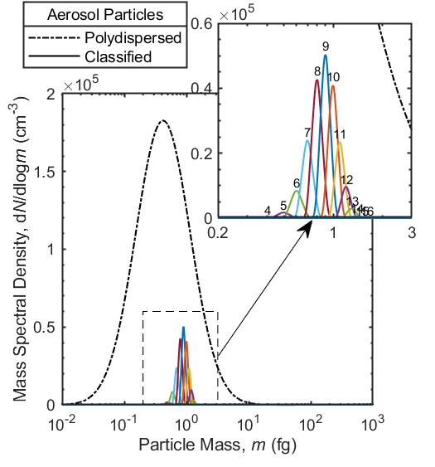
Figure S1. A representative mass distribution for particles transmitted through the CPMA after the UDAC. The example shows the input mass distribution (black line) and output mass distributions of particles with $1<q<15$ for miniCAST-D particles with $m/q=0.1$ fg/e at a CPMA resolution of 3 and UDAC setpoint of 4.2 × 10¹³ ions⋅s/m³. The sum of all outputs may be approximated as a lognormal distribution.

Figure S2. MAC_{550nm} calculated using the three average-single-particle-mass approaches for the CAPS PM_{SSA} data measured at 660 nm. Some error bars are omitted for clarity. Fewer data points are available through the system of equations for the statistical reasons described in the text. Therefore, other figures in this work used the second data set (average mass from charge-and-mass distributions, with minimal assumptions).

Figure S3. Similar to Figure S1 but for all CPMA setpoints in the Diesel generator experiment. The CPMA setpoint is illustrated by the intercept of the curves on the ordinate axis and is between 0.05 and 0.30 fg/e. The probability distribution of charges is shown by each curve. The mean charge is shown by the values on the right.

Figure S4. Comparison of the mean CPMA-transmitted single-particle mass from the iterative-average-charge (IAC) method and the average single-particle mass methods.

Figure S5. Band-gap energies $E_{g}$ (lower panel) and absorption functions $E(m)$ (upper panel) corresponding to the measurements discussed in the main text. The vertical pink lines highlight the range of reported size-dependent MACs shown in Figure 5. All curves were calculated with Equations 8, 9, and 10, similar to Ref. [39], RI $1.66+0.76i$, and $h=1.14$ as calculated from the GMM-1 and RDG-0 models (main text). The three sets of curves represent different assumptions about particle density in Equation 8. In particular, the curves assume the density of mature soot, nascent (young) soot, or a maturity-dependent density based on the carbon/hydrogen-ratio (C/H) and parameterized by [74]. Although the parameterization of [74] assumed $E_{g}=0.25$ eV for mature soot, we have extrapolated down to 0 eV for illustration. This parameterization may not be applicable for all flames discussed in the main text, and it does not predict the upper range of MACs reported in the main text.

Figure S6. Measured and modelled size-resolved MACs for the Gnome aviation turbine engine. The fit to the measurements highlights the observed sigmoidal trend. We modelled 3 hypotheses for size-dependent soot properties (GMM-1, GMM-2, and RDG-3). The null-hypothesis model (RDG-0) assumes DLCA aggregates of constant $d_{pp}$ and RI. The GMM-1 model accounts for internal scattering within the soot aggregate. The GMM-2 model implements the correlation of $d_{pp}$ with $d_{m}$ (and $m_{p}$) observed previously [27,58,63]. The graphitic-shell model extends the correlation model to hypothesize that the extreme curvature of smaller soot particles makes them less graphitic. Finally, the GMM-3 model represents quantum confinement following Ref. [35]; it does not represent the $d_{pp}$ of this engine.

Figure S7. Similar to Figure 5 but with data overlaid on a single panel.

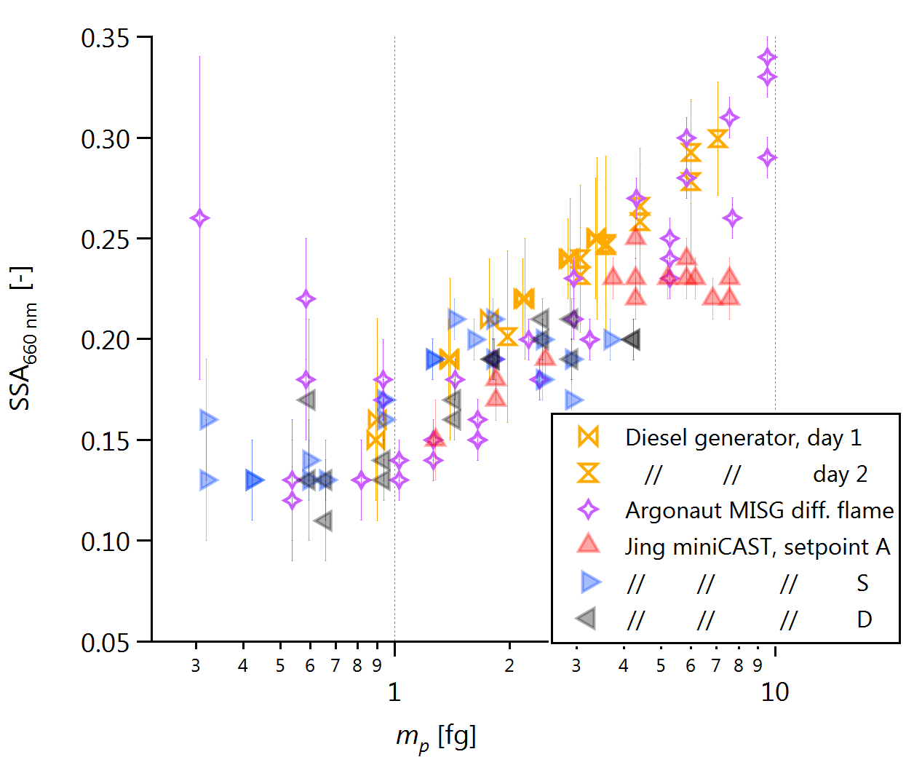
Figure S8. Single scattering albedo (SSA) versus single-particle mass for the 660 nm CAPS PM_{SSA} data.
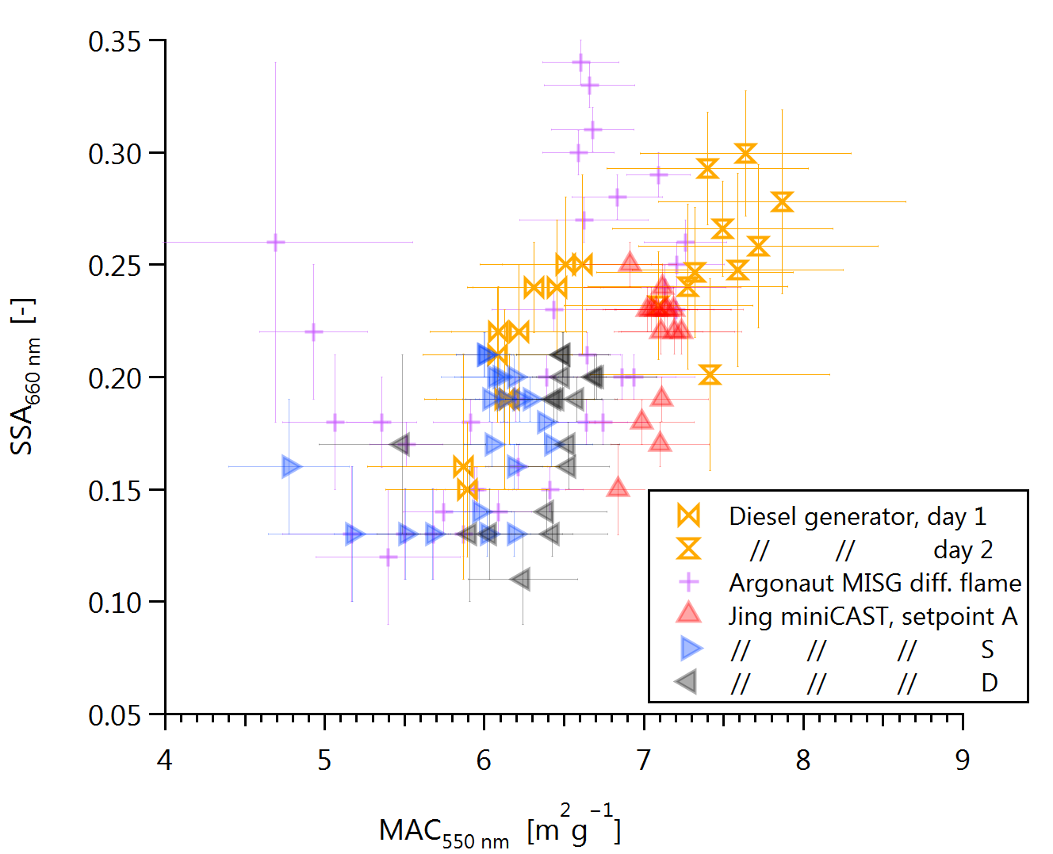
Figure S9. Single scattering albedo (SSA) versus MAC_{550nm} for the 660 nm CAPS PM_{SSA} data.

Figure S10. Calibration of the MSS used in this study using the Gnome data shown in Figure 3, Figure S6, and other figures. The size-resolved MAC signal results in a scatter of only approximately 10% in the calibration scatterplot and residuals. However, this scatter is systematic enough to allow for the size-resolved MAC to be inferred, as discussed in the manuscript.

Aerosol pressure and temperature of 101,325 Pa and 298.15 K, respectively, as well as assuming the soot particles follow the mass-mobility relationship established by Olfert and Rogak [58].
The width of the classified mass distribution is a function of the combined widths of the particle charge distribution, CPMA transfer function and polydispersed aerosol.

