Self-healing hydrogel as carrier of photosensitizers based on polythiophene/ boron nitride nanotubes for photodynamic therapy of cancer cells
Natalia Pettinelliª, Yadienka Martinez-Rubi^{b}*, Saddys Rodríguez-Llamazaresª*, Iván González-Chavarría^{c}, Zygmunt J. Jakubek^{d}, Rebeca Bouza^{e}, María Paz Castillo^{c}, Yerko Rivas^{c}, Nery Jara^{f}, Jianfu Ding^{b}, Christopher Kingston^{b}

Characterization of the functionalized BNNTs

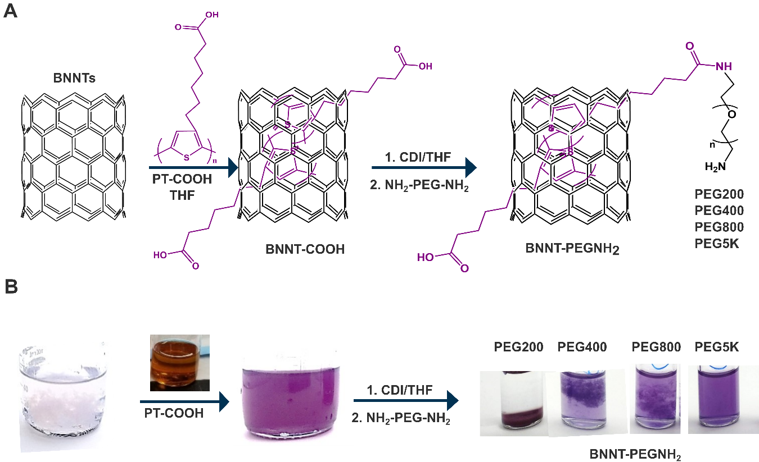
Figure S1. (a) Schematic of the noncovalent functionalization of BNNTs with PT-COOH and coupling of different molecular weight bifunctionalized PEG linkers (NH₂-PEG-NH₂). (b) Photos of corresponding BNNT, BNNT-COOH and BNNT-PEGNH₂ dispersions in THF.

- Time-dependent stability
The time-dependent stability of the PT-BNNT dispersions was evaluated by comparing the UV-VIS spectra recorded at time 0 and after 12 days. A decrease in the intensity of the extinction absorption spectrum was observed for both BNNT-COOH and BNNT-PEGNH₂, with scattering component decreased and absorption unchanged. Since no significant changes to the shape and absorbance of the structured absorption band were observed this would indicate that the structure of the noncovalently bound polymer is not changing with time. Decreased scattering component would indicate improved dispersion of individualized PT-BNNT particles and/or sedimentation or large particles. SEM images of the sediment and the resultant dispersion shows that mainly h-BN impurities, which are present in the BNNT material, are identified as the particles separating out of the dispersion. SEM results agree with the low specific surface area of h-BN impurities (Martinez-Rubi et al., 2019) and poor interaction with the conjugated polymers leading to a poor dispersibility of the impurities. The stability of the dispersions is further supported by high negative surface charge and/or steric repulsion of PEG.
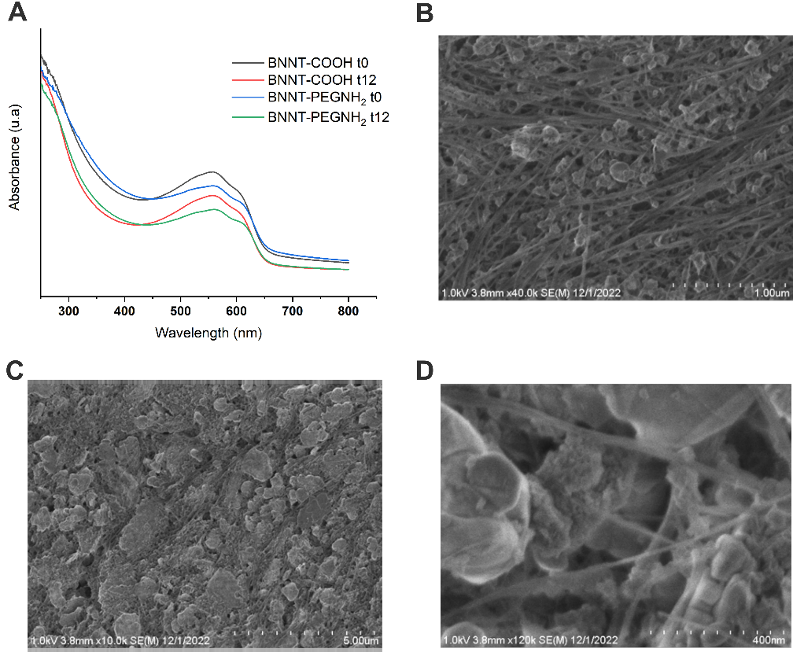
Figure S2. Evaluation of the time-dependent stability of functionalized BNNTs in water. A) UV-VIS absorption spectra of BNNT-COOH and BNNT-PEGNH₂ at 0 and 12 days: B) SEM image of the remaining dispersion and C and D) SEM images of the sediment.

Characterization of chitosan/dialdehyde starch/BNNTs hydrogels
- Attenuated total reflectance ATR-FTIR spectroscopy

Dialdehyde corn starch and corn starch were characterized by Fourier transform infrared (FTIR) spectroscopy on an Agilent Cary 630 FTIR spectrometer with Diamond attenuated total reﬂectance (ATR) (USA) as the sample interface. The ATR-FTIR spectra of samples were recorded by averaging the signals of 32 scans at 4 cm⁻¹ of resolution in the range from 4000 cm⁻¹ to 500 cm⁻¹.
- Determination of aldehyde content
Aldehyde content of the DCS was determined by iodometric titration according to Vahedi et al.(Vahedi et al., 2020; Yu et al., 2010). Briefly, DCS (0.2 g) was added to 25 mL of 0.25 M hydroxylamine hydrochloride solution at 50 °C for 3 h by magnetic stirring. The pH was adjusted to 5 with 0.1 M NaOH solution (V _{sample}, mL), and the volumes added during the reaction were recorded. The same reaction was also carried out for pure starch, as a control, to determine the volume of NaOH solution (V _{control}, mL) to keep the pH constant at 5. Finally, the aldehyde content of DCS was determined by the following equation (1) as moles of aldehyde per 1 g of DCS sample:
$\frac{CHO(mol)}{1g sample}=\frac{M_{NaOH} x \left(V_{sample}\right.-\left.V_{control}\right)}{g_{sample} x 1000}=\frac{ 0.1 x \left(V_{sample}\right.-\left.V_{control}\right)}{0.2 x 1000}$ (1)
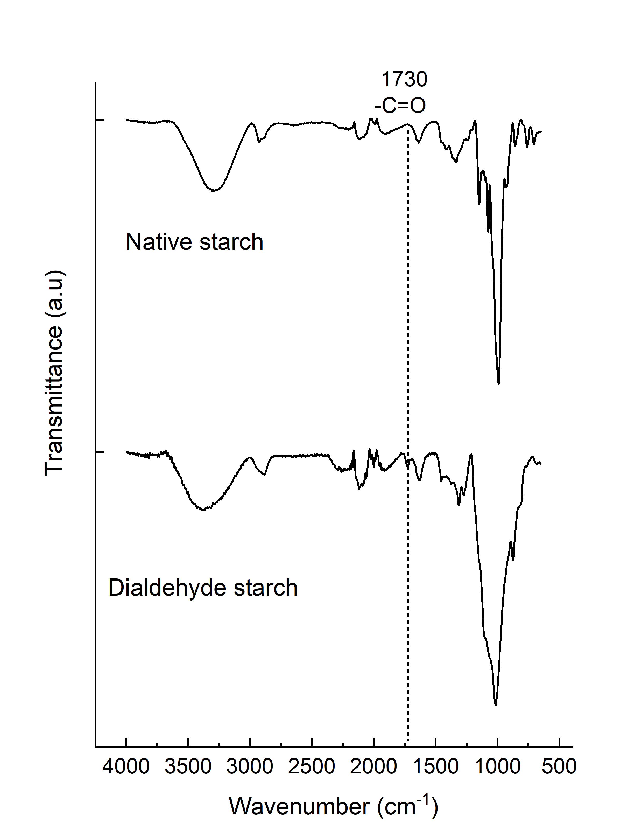
Figure S3. (A) FTIR spectra of native corn starch and oxidized starch (dialdehyde corn starch, DCS) For DCS a new peak is observed at 1730 cm⁻¹, characteristic for C=O group of the dialdehyde product of the OH groups oxidation process (Zhang, Liu, Wang, & Gao, 2011).
Table S1. Self-recovery values of the hydrogels after low (1%) and high (100%) strain cycles with respect to the initial values of G'.
Samples | Recovery respect to first cycle (%)
Samples | Cycle 2 | Cycle 3 | Cycle 4
H-0 | 83 | 72 | 73
H-BNNT | 82 | 83 | 82
H-BNNT-COOH | 79 | 79 | 78
H-BNNT-EO | 78 | 78 | 81
H-BNNT-PEGNH₂ | 75 | 77 | 79

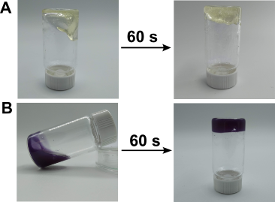
Figure S4. Photographs of H-0 (A) and H-BNNT-OH (B) self-healing hydrogels formed immediately after the mixing of a 4% solution of chitosan and a solution of dialdehyde starch at 25 ℃.

Video S1. Self-healing of H-0
Video S2. Self-healing of H-BNNT-COOH

- Swelling behavior and degradation assays of hydrogels

The swelling behaviors of hydrogels were determined by immersing the weighed and fresh hydrogels in water at 25°C. The swollen hydrogels were weighed daily after removing the water until equilibrium was reached. The swelling ratio (SR) was calculated by the Eq. 1:
$SR \left(\%\right)= {\left(W_{s}-W_{d}\right)}/{{W_{d} }_{ }x 100}$ (1)
where W_{s} is the weight of swollen hydrogel and W_{d} is the weight of fresh hydrogel.
To determine the degradation of the hydrogels, hydrogel samples were prepared and freeze-dried. Then, each hydrogel was weighed and placed in PBS solution at 37 °C under static conditions. These hydrogels were removed, freeze dried and weighed again at 7 and 14 days of incubation to determine the final dry weight. The weight loss of the samples was calculated by Eq. (2) (Pettinelli et al., 2020):
$Weight loss \left(\%\right)= {\left(W_{i}-W_{f}\right)}/{W_{i} x 100}$ (2)
where W_{i} and W_{f} are the dried weights of the hydrogels before and after the incubation in the PBS solution, respectively.
The swelling behavior of the hydrogels was evaluated in water at 25 °C. The hydrogels exhibited swelling ratios (SRs) of 662%, 611%, 686%, 715%, and 913% for H-0, H-BNNT, H-BNNT-COOH, H-BNNT-EO, and H-BNNT-PEHNH₂, respectively. The SR of H-BNNT-PEHNH₂ was higher, possibly due to the presence of PEG, which provides hydrophilicity to the network, and the protonation of the NH₂ groups in water, which generates electrostatic repulsion and increases the swelling capacity. These values were higher than the swelling ratio values previously reported for chitosan-starch-based hydrogels crosslinked through Schiff's base (Liu et al., 2020; Liu et al., 2020; Aslzad et al., 2022).
The degradation of the H0 hydrogel was evaluated after 7 and 14 days in a phosphate-buffered saline (PBS) solution at 37 °C. After seven days, it was observed that the H-0 hydrogel had degraded by 2.6 ± 0.7 % (Fig. 3). After 14 days, the degradation rate was 11.1 ± 2.9 %. Degradation of these hydrogels occurs mainly by hydrolysis of the imine bonds (Schiff's base) linking the polymeric chains. These bonds are reversible and susceptible to hydrolysis in the presence of water. Schiff-base linkages are cleaved via hydrolysis of the imine bond especially at low pH, resulting in the breakdown of the polymeric network and, thus, in the degradation of the hydrogel (Jalalvandi & Shavandi, 2018). The values obtained were lower than those reported in previous studies of Schiff's crosslinked dialdehyde starch/chitosan-based hydrogels, which showed degradation ranging from 20% to 80% in phosphate-buffered saline (PBS) at 37°C after two weeks (Liu et al., 2020; Aslzad et al., 2022).
- Cell assays

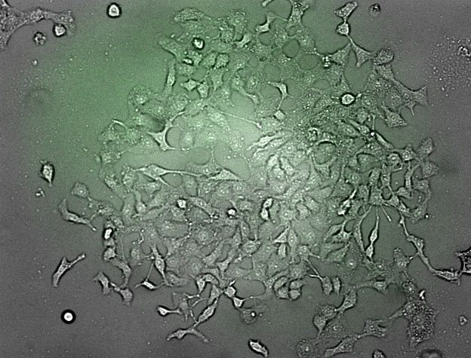
Figure S5. Confocal microscopy images of cells treated with only light (control). Images were captured at 10X magniﬁcation. The fluorescence intensity in the cells indicates the production of reactive oxygen species (ROS) using the general oxidative stress indicator CM-H2DCFDA.

References
Aslzad, S., Savadi, P., Abdolahinia, E. D., Omidi, Y., Fathi, M., & Barar, J. (2022). Chitosan/dialdehyde starch hybrid in situ forming hydrogel for ocular delivery of betamethasone. Materials Today Communications, 33, 104873.
Jalalvandi, E., & Shavandi, A. (2018). In situ-forming and pH-responsive hydrogel based on chitosan for vaginal delivery of therapeutic agents. Journal of Materials Science: Materials in Medicine, 29, 1-11.
Liu, Q., Ji, N., Xiong, L., & Sun, Q. (2020). Rapid gelling, self-healing, and fluorescence-responsive chitosan hydrogels formed by dynamic covalent crosslinking. Carbohydrate Polymers, 246, 116586.
Liu, J., Li, J., Yu, F., Zhao, Y. X., Mo, X. M., & Pan, J. F. (2020). In situ forming hydrogel of natural polysaccharides through Schiff base reaction for soft tissue adhesive and hemostasis. International Journal of Biological Macromolecules, 147, 653-666.
Martinez Rubi, Y., Jakubek, Z. J., Chen, M., Zou, S., & Simard, B. (2019). Quality assessment of bulk boron nitride nanotubes for advancing research, commercial, and industrial applications. ACS Applied Nano Materials, 2(4), 2054-2063.
Pettinelli, N., Rodriguez-Llamazares, S., Bouza, R., Barral, L., Feijoo-Bandin, S., & Lago, F. (2020). Carrageenan-based physically crosslinked injectable hydrogel for wound healing and tissue repairing applications. International journal of pharmaceutics, 589, 119828.
Zhang, L., Liu, P., Wang, Y., & Gao, W. (2011). Study on physico-chemical properties of dialdehyde yam starch with different aldehyde group contents. Thermochimica Acta, 512(1-2), 196-201.

